

**JOB DESCRIPTION**

Material Analyst Shall

1. Plan and execute the timely procurement of assigned SD/TA materials to support engineering and operations activities.
2. Execute the timely procurement of assigned materials, purchase requisitions and project reservations to maintain optimum stock levels and comply with customer requirements.
3. Update and maintain the assigned Materials Management System Database (MESC etc.) to support the accuracy and integrity of the database.
4. Arrange materials ordering on “incoterms” to facilitate the cost effective movement ex-factory to SASREF site.
5. Execute the periodic review of materials movement and recommend actions for optimization to ensure an efficient, cost effective inventory is maintained.
6. Update the purchase order delivery system to support development of management reports.
7. Validate materials invoices using “three way mis-matches” to support timely payment of suppliers.
8. Controls assigned inventory to support maintenance of adequate stock levels.
9. Plan & procure materials in an efficient and cost effective manner.
10. Review materials movements and recommend actions to optimize the inventory.
11. "The job holder is responsible for the prudent supply of materials at competitive prices, he communicates with various user departments to establish specification needs and facilitate the selection of material to be ordered.
12. Periodically review material inventory and recommend obsolescence / revaluation.
13. Verify and identify any special requirements, liaise with Engineering Planners for shutdown / turn-around materials requirements."

**QUALIFICATION**

1. Secondary education plus 2 years formal training leading to a Diploma in Materials Management.
2. Minimum of 8 Year’s experience in the field of materials & supply chain management in the petrochemical industry.
3. Very good English language skills and competent in the use of PC applications (MS Office suite or equivalent).
4. Inventory management and Purchasing.
5. Agreements and contracts.
6. Drive for Excellence.
7. Organizational Commitments

**Contact**

**Send you Cv’s to** [**job@mazco.com.sa**](mailto:job@mazco.com.sa)

**Or**

**Post Box: 2486, Dammam 31451,**

**KINGDOM OF SAUDI ARABIA.**

**Tell: +966 3 8260080 EXT: 31**

**Fax : +966 3 8266618**

**Website::**[**www.mazco.com.sa**](http://www.mazco.com.sa)

[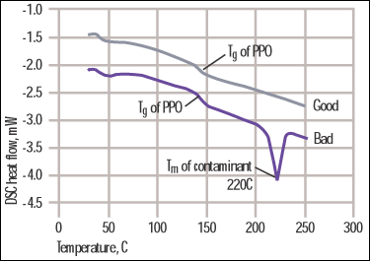](http://www.google.com.sa/url?sa=i&rct=j&q=Material+Analyst&source=images&cd=&cad=rja&docid=GqrIikQbn-gI0M&tbnid=-bzxYH-e78yZjM:&ved=0CAUQjRw&url=http://www.plasticstoday.com/articles/materials-analyst-part-41-contamination-derails-welding-process&ei=duhWUZvgJsjdPe2AgagN&psig=AFQjCNHaTPpvkhvoW_h2VHbB6VTZ5npmWw&ust=1364736462851241)

Material Analyst